EXERCISE 10
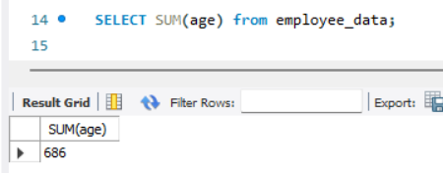
- Display the sum of ages of employees working at Bignet.

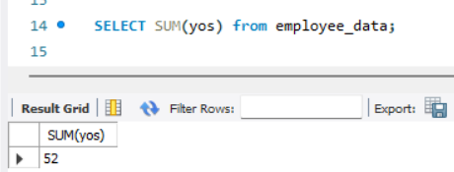
- How would you calculate the total of years of service the employees of Bignet have in the company?

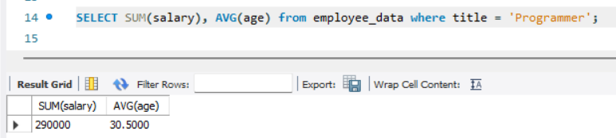
- Calculate the sum of salaries and the average age of employees who hold “Programmer” title

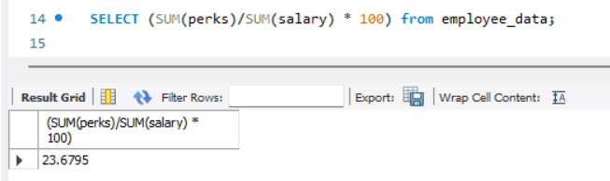
- What do you understand from the following statement?

The statement calculates the total perks of the employees, then calculate the total salary of employees then add the total perks to the total salary and the result is then multiplied by 100 which represents the total percentage of perks.

